Project #3 Image Enhancement
Due Thursday September 29th.

Histogram transformations

Histogram specification of the Phobos image (Figure 1) was used to bring out details in the dark section of the image.

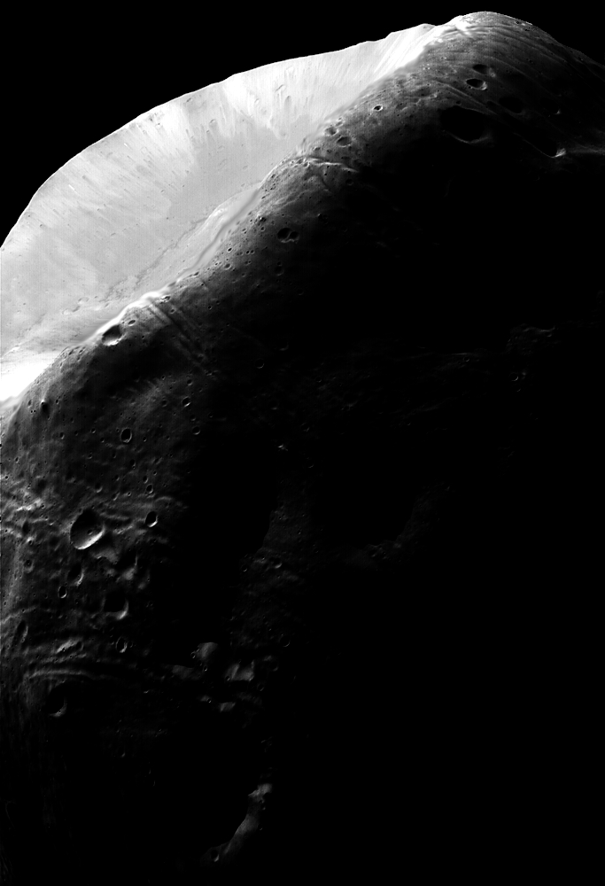
Figure 1. Photo of Phobos taken by Mars Global Surveyor. Figure 3.23 of Gonzalez and Woods.

Your assignment is to improve the visible detail in the dark areas of this photograph. The photograph is available from Blackboard.

1. Use the MATLAB routine imadjust (or equivalent) to contrast stretch the image.
2. Use the MATLAB routine histeq (or equivalent) to histogram equalize the image.
3. Write a program which expands the dynamic range of the dark pixels in the image. This is histogram specification as discussed in class. You may use the same approach described in class and the textbook or another of your choice.

Project #3
Suggested Format for Submitting Project Reports
Page 1. Cover Page. Typed or printed neatly.
* Project title
* Project number
* Course number
* Student's name
* Date due
* Date handed in
* Abstract (not to exceed 1/2 page)
Page 2. Technical discussion. One to two pages (max). This section should include the techniques used and the principal equations (if any) implemented.
Page 3 (or 4). Discussion of results. One to two pages (max). A discussion of results should include major findings in terms of the project objectives, and make clear reference to any images generated.
Results. Includes all the images generated in the project. Number images individually so they can be referenced in the preceding discussions.

The majority of your grade comes from Page 3. Some typical subjects which you can address include:
- Use the histogram of the original image as your reference for discussion.
- Can a point transform such as a contrast stretching achieve the same effects as a histogram equalization or specification?
- Explain why there are gaps in the histogram of a histogram equalized or specified image.
- Do you think your best result is better than the one described in GWE?

Appendix. Program listings. Includes listings of all programs written. Standard routines and other material obtained from other sources should be acknowledged by name, but their listings should not be included.
Layout. The entire report must be in standard sheet size format (8.5 x 11 inches) All sheets should be stapled. Alternatively, you may electronically submit the entire project. Your report can include .doc or .pdf report files, any appropriate image files. Your program files (M-files, etc.) should be included.
A note on program implementation: You may write your program in any language you wish. Exceptional programs will be demonstrated in class.

